
Scheme of Delegation
Objectives for the Scheme of Delegation
To ensure the Scheme of Delegation makes it clear what is expected of all key stakeholders in governance of the trust and its academies. This will be achieved by:
- An overview of the guiding principles being followed (based on ethos and vision for the trust) when determining the allocation of responsibilities (WHY)
- More detailed listing of the governance tasks/responsibilities across the trust to improve clarity on the governance work required, linking these to the three core strategic functions of governance (WHAT)
- To provide more clarity on the role of each governance stakeholder and the specifics of their responsibilities (WHO)
- To provide a structure which can be built upon with the addition of Governance Role Profiles for roles such as Safeguarding governor, Pupil Premium Governor and so on.
Details on the ‘WHEN’ and ‘HOW’ will be provided in an improved Governance Handbook and Governance Role Profiles

Introduction
This scheme of delegation provides guidance of what is expected of each level of governance within the Berlesduna Academy Trust and who has responsibility for what. It should be used as a reference/checklist for those involved in governance and should be read in conjunction with other key documents, dependant on role, as detailed below:
Members and trustees: Articles of association, Terms of reference for committees, Code of Conduct
Local governors: Terms of reference for local boards, specific role profiles for individual link governors, Code of Conduct
All involved in governance should also reference the DfE Governance Handbook and Governance Competency Framework.
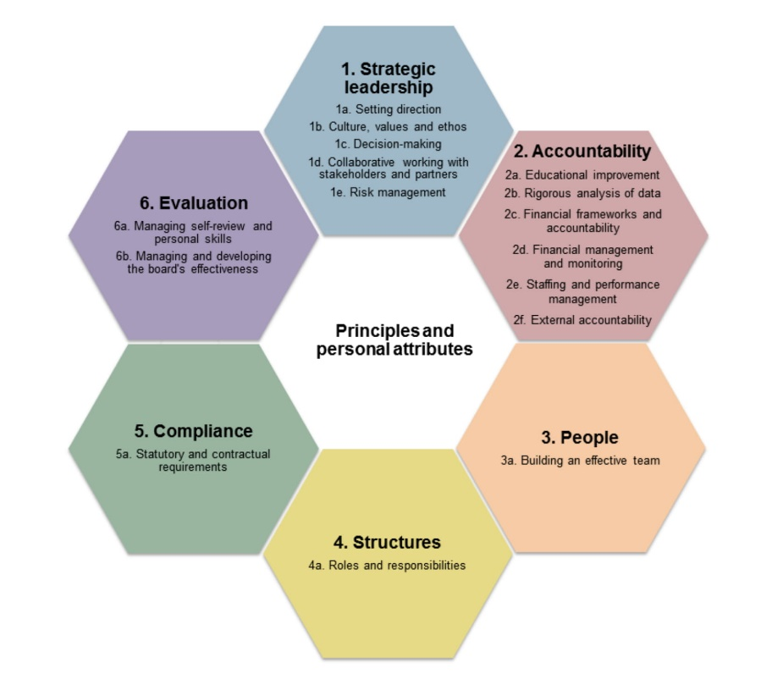
The DfE Governance Competency Framework
Purpose of Governance
The DfE Governance Handbook makes it clear what is expected of those involved in governance. It states:
“The purpose of governance is to provide confident, strategic leadership and to create robust accountability, oversight and assurance for educational and financial performance”.
All Boards, no matter what type of school or how many schools they govern have three core functions:
- Ensuring clarity of vision, ethos and strategic direction
- Holding executive leaders to account for the educational performance of the organisation and its pupils, and for the performance management of staff
- Overseeing the financial performance of the organisation and making sure its money is well spent
This scheme of delegation clarifies how these core functions are met across the Berlesduna Academy Trust.
Vision and Values
Vision Statement
The vision of the Berlesduna Academy Trust is to create and foster a culture of high aspiration, enjoyment for learning, academic success and lifelong skills amongst all pupils, regardless of their social, economic or cultural background.
Aims and Values
The aim is to become a strong local partnership of schools. Whilst we aim to build a strong and cohesive identity, we recognise that each school within the Trust has its own unique characteristics. Collaboration and joint working ensure that all schools within the Trust can share in, and benefit from, each other’s strengths. The aim as an Academy Trust is to work together to:
• make a positive difference to the lives of the pupils
• have an unflinching commitment to closing the gap between high and low performers within the schools
• transform the learning conditions of others so that growth, commitment, engagement, and constant spawning of leadership in others is being fostered.
Structure of the Berlesduna Academy Trust
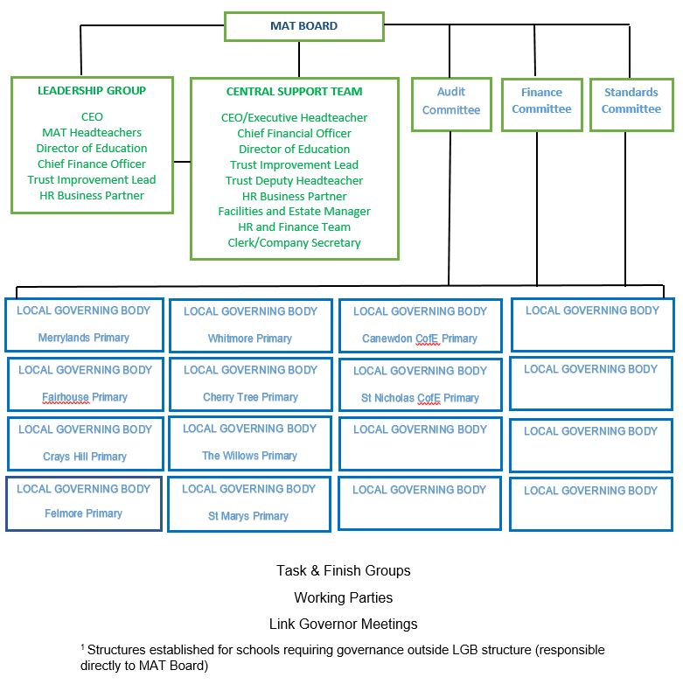
Delegation Matrix
Key to levels of delegation
Level 1: Berlesduna Trust Board (B-= Full Board, F= Finance Committee, S= Standards Committee, A= Audit Committee, M= Members)
Level 2: CEO of the trust or delegated to trust directors
Level 3: Local Governing Board (assumes headteacher is part of the LGB)
Level 4: Headteacher
Key Function | Ref | Tasks | Delegation Level |  |  |  | Notes
Key Function | Ref | Tasks | 1 | 2 | 3 | 4
1. Vision, ethos and strategic direction | 1.1 | Setting and safeguarding an ethos of high expectations for the trust | B | ü |  |  | The ethos of the trust will be set, communicated and monitored across the trust by trustees with support from the CEO. LGBs to ensure the ethos of the academy supports/embraces the ethos of the trust. Trustees should monitor the ethos across the trust
1. Vision, ethos and strategic direction | 1.2 | Setting and monitoring the vision for the trust | B | ü |  |  | Ensure there is a 3-5 year vision for the trust, that is shared with all stakeholders. The vision for each academy should complement this.
1. Vision, ethos and strategic direction | 1.3 | Setting and monitoring strategic direction for the trust | B | ü |  |  | Ensure there is a 3 year high level strategic plan to achieve the vision and KPIs to monitor and evaluate progress across the trust
1. Vision, ethos and strategic direction | 1.4 | Setting and monitoring annual improvement plan for the trust | B | ü |  |  | Ensure there is an annual strategic improvement plan for the trust that reflect the vision and sets targets for trust KPIs. The plan must contain SMART targets that trustees can monitor/gather evidence of in order to hold to account. Gathering data trust wide to monitor and evaluate trends and impact of improvement
1. Vision, ethos and strategic direction | 1.5 | Stakeholder engagement (inc media and PR) for the trust | B | ü |  |  | Ensure that all stakeholders have a voice across the trust and their views are an input into the strategic direction of the trust. Communicate with stakeholders as a trust.
1. Vision, ethos and strategic direction | 1.6 | Identifying and monitoring risks for the trust | A | ü |  |  | Ensure there is a risk management plan that is updated and monitored termly in order to mitigate and manage risks for the trust. Keep the risk profile of the trust under review. (Audit and Risk Committee)
1. Vision, ethos and strategic direction | 1.7 | Setting and safeguarding the ethos of the academy |  |  | ü | ü | Ensure the ethos reflects the ethos of the trust and is clear and understood by all stakeholder. This should reflect British values and show high aspiration for all
1. Vision, ethos and strategic direction | 1.8 | Setting and monitoring the vision for the academy |  |  | ü | ü | Lead the creation of a shared vision that complements the trust vision. Ideally for 3-5 years. It should be clear to stakeholders from this the direction of travel for the school.
1. Vision, ethos and strategic direction | 1.9 | Setting and monitoring strategic direction for the academy |  |  | ü | ü | Ensure there is a 3-5 year high level plan to achieve the vision
1. Vision, ethos and strategic direction | 1.10 | Setting and monitoring annual improvement plan for the academy |  |  | ü | ü | Ensure there is an annual strategic improvement plan for the academy that reflect the vision and sets targets for academy KPIs. The plan must contain SMART targets that governors can monitor/gather evidence of in order to hold to account.
1. Vision, ethos and strategic direction | 1.11 | Identifying and monitoring risks for the academy |  |  | ü | ü | Ensure there is a risk management plan that is updated and monitored termly to mitigate and manage risks for the academy. Keep the risk profile of the trust under review and share with trustees (Audit and Risk Committee)
1. Vision, ethos and strategic direction | 1.12 | Listening to stakeholders and engaging them in strategy and vision |  |  | ü | ü | Ensure the local board listens to stakeholders and takes on board their views when making strategic decisions. This can be achieved through surveys or other listening activities

Key Function | Ref | Tasks | Delegation Level |  |  |  | Notes
Key Function | Ref | Tasks | 1 | 2 | 3 | 4 | Notes
2. Academy Improvement | 2.1 | Agreeing KPIs for the trust and reporting mechanisms and frequency of these | B | ü |  |  | These will be set trust wide to ensure consistency of reporting and comparison across the trust. They will be communicated across the trust by the CEO. Recommendations of CEO and committees
2. Academy Improvement | 2.2 | Monitoring and holding to account against educational performance KPIs and the annual improvement plan targets | S | ü | ü |  | LGBs responsible at local level, trust wide monitoring by CEO and trust board
2. Academy Improvement | 2.3 | Oversight and monitoring and evaluation of the intent, implementation, and impact of the curriculum | S | ü | ü |  | LGBs responsible at local level, trust wide monitoring by CEO and trust board
2. Academy Improvement | 2.4 | Review MAT performance against national averages  and review trends from Inspection Data Summary Reports for academies | S | ü |  |  | Review and benchmark academies performance in the trust against national averages and challenge any under-performance
2. Academy Improvement | 2.5 | Oversight and monitoring of pupil behaviours, as per agreed KPIs and targets | S | ü | ü |  | LGBs responsible at local level, trust wide monitoring by CEO and report to trust board
2. Academy Improvement | 2.6 | Oversight and monitoring of pupil personal development as per agreed KPIs and targets | S | ü | ü |  | LGBs responsible at local level, trust wide monitoring by CEO and report to trust board
2. Academy Improvement | 2.7 | Review academy performance against national comparisons and review IDSR |  | ü | ü |  | Annual review and benchmarking of performance. Challenge any underperformance
2. Academy Improvement | 2.8 | Report the performance of the academy against KPIs, performance targets and national averages |  |  |  | ü | Deliver data in the format and at the frequency agreed to enable the committees and the board to do their job
2. Academy Improvement | 2.9 | Deliver school improvement in line with the agreed KPI and Performance Targets |  |  |  | ü

Key Function | Ref | Tasks |  | Delegation |  |  |  |  |  |  |  | Notes
Key Function | Ref |  |  | 1 |  | 2 |  | 3 |  | 4 |  | Notes
3. Quality of Education | 3.1 | Ensure the national curriculum guidelines are met and consider any disapplication |  | S |  | ü |  | ü |  |  |  | Monitor to ensure the curriculum is compliant, inclusive and effective
3. Quality of Education | 3.2 | Establish curriculum Intent and Implementation approach |  | S |  | ü |  | ü |  | ü |  | Ensure that there is a clear strategy for the curriculum, its development and implementation, including accuracy of assessment, subject leadership and resource management
3. Quality of Education | 3.3 | Monitor curriculum implementation and impact |  |  |  |  |  | ü |  |  |  | Monitor progress against the curriculum strategy and its impact on quality of education, progress and attainment.
3. Quality of Education | 3.4 | Set assessment approach |  |  |  |  |  |  |  | ü |  | Ensure consistency and accuracy of assessment for all subjects
3. Quality of Education | 3.5 | Monitor accuracy of assessment |  |  |  | ü |  | ü |  | ü |  | Review assessment results in-year and actuals v predictions
3. Quality of Education | 3.6 | Monitor sex and relationship education |  |  |  | ü |  | ü |  |  |  | Ensure there is a clear strategy, an up to date policy and compliance with this
3. Quality of Education | 3.7 | Monitor promotion of British values |  |  |  | ü |  | ü |  |  |  | Ensure that all British values are actively promoted through the SMSC curriculum
3. Quality of Education | 3.8 | Implement actions to maintain teaching standards and quality of teaching |  |  |  | ü |  |  |  | ü |  | Facilitate individual and generic support and training for all teaching staff to ensure quality first teaching which is improving over time
3. Quality of Education | 3.9 | Monitor quality of teaching |  | S |  | ü |  | ü |  | ü |  | Monitor trends and outcomes across the school comparing with performance management reviews (anonymised)
3. Quality of Education | 3.10 | Monitor impact and value for money of CPD |  | F |  | ü |  | ü |  |  |  | Review strategy, spend and impact of CPD and perceptions/satisfaction by staff
3. Quality of Education | 3.11 | Monitor provision and outcomes across the trust for vulnerable pupils and the impact of any other grants |  | S |  | ü |  | ü |  |  |  | Review effectiveness of provision, budget and impact
3. Quality of Education | 3.12 | Monitor the impact of the SEND provision and outcomes for SEND pupils across the trust |  | S |  | ü |  | ü |  |  |  | Review effectiveness of provision, budget and impact
Key Function | Ref | Tasks | Delegation |  |  |  |  |  |  |  | Notes
Key Function | Ref | Tasks | 1 |  | 2 |  | 3 |  | 4
4. Finance and assets | 4.1 | Agree funding model across the trust | F |  |  |  |  |  |  |  | Agree the funding model and communication of this
4. Finance and assets | 4.2 | Recommend the academy budget and any revisions to this to the trust board |  |  |  |  | ü |  | ü |  | Recommend a budget that represents value for money, and facilitates the agreed strategy for the academy
4. Finance and assets | 4.3 | Determine and allocate trust central services | F |  | ü |  |  |  |  |  | Provide clarity on central services and any SLAs. Monitor effectiveness and value for money
4. Finance and assets | 4.4 | Approve academy budgets and the overall trust budget for the year | B/F |  | ü |  |  |  |  |  | Detailed discussions at Finance Committee and recommendation to board
4. Finance and assets | 4.5 | Monitor monthly income and expenditure against budget plans | F |  |  |  |  |  |  |  | Review actual spend against budget and hold to account
4. Finance and assets | 4.6 | Termly monitoring of income and expenditure against plans |  |  |  |  | ü |  |  |  | Review presented financial data and respond from any direction from the CFO
4. Finance and assets | 4.7 | Ensure compliance with Academies Financial Handbook | A |  |  |  |  |  |  |  | Monitor financial compliance
4. Finance and assets | 4.8 | Review value for money and benchmark spending and impact of spend | F |  | ü |  |  |  |  |  | Use benchmarking tools/information to challenge budget spend effectiveness. Review staffing model and impact
4. Finance and assets | 4.9 | Set and monitor procurement policies and processes trust wide | F |  | ü
4. Finance and assets | 4.10 | Ensure procurement procedures are followed and robust | A |  | ü |  |  |  |  |  | Audit compliance and monitor management to avoid fraud or error
4. Finance and assets | 4.11 | Ensure value for money procurement across the trust |  |  | ü |  |  |  |  |  | Identify areas for improved financial effectiveness and recommend improvement strategies
4. Finance and assets | 4.12 | Review and approve contracts within procurement policy |  |  | ü |  | ü |  |  |  | Ensure contracts represent value for money and are tendered as appropriate
4. Finance and assets | 4.13 | Complete audit functions and report financial scrutiny to ESFA | A |  |  |  |  |  |  |  | Ensure compliance with audit requirements and financial scrutiny requirements
4. Finance and assets | 4.14 | Agree and monitor asset and premises plans and management | F |  | ü |  |  |  |  |  | Identify risks and works/investment required and budget accordingly
4. Finance and assets | 4.15 | Review of staffing structures | F |  | ü |  | ü |  | ü |  | Review value for money and impact of staffing structures
4. Finance and assets | 4.16 | Monitor pupil numbers and staff ratios | F |  | ü |  | ü |  | ü |  | Looks at trends, fluctuations, and stability
4. Finance and assets | 4.17 | Approve and oversee compliance with financial regulations | A |  | ü |  |  |  |  |  | Set, communicate and monitor compliance with financial regulations and monitor corrective actions are completed
 | 4.18 | Review feedback from local internal audits and monitor implementation of actions | A |  | ü |  | ü |  | ü |  | Review internal audit reports and ensure actions are addressed
Key Function | Ref | Tasks |  | Delegation |  |  |  |  |  |  |  | Notes
Key Function | Ref |  |  | 1. |  | 2. |  | 3. |  | 4. |  | Notes
5. HR | 5.1 | Appointment of CEO |  | B |  |  |  |  |  |  |  | Agree process and requirements and ensure safer recruitment practices
5. HR | 5.2 | Performance management, discipline and dismissal of CEO |  | B |  |  |  |  |  |  |  | Ensure clarity of role profile, annual performance targets and expectations. Monitor and hold to account. Refer to policies
5. HR | 5.3 | Appointment of Headteacher/head of school |  | B |  | ü |  | ü |  |  |  | Agree process and requirements and ensure safer recruitment practices
5. HR | 5.4 | Appointment of senior staff at an academy |  |  |  | ü |  | ü |  | ü
5. HR | 5.5 | Performance management of headteachers |  | F |  | ü |  | ü |  |  |  | Ensure clarity of role profile, annual performance targets and expectations. Monitor and hold to account Managed locally, Finance committee to have oversight
5. HR | 5.6 | Discipline and dismissal of headteachers |  | B |  | ü |  |  |  |  |  | Refer to policies
5. HR | 5.7 | Appointment of trust staff |  | B |  | ü |  |  |  |  |  | Agree process and requirements and ensure safer recruitment practices. Board involvement for directors only
5. HR | 5.8 | Performance management of trust staff |  | F |  | ü |  |  |  |  |  | Ensure clarity of role profile, annual performance targets and expectations. Monitor and hold to account. Finance committee to approve
5. HR | 5.9 | Discipline and dismissal of trust staff |  | F |  | ü |  |  |  |  |  | Refer to policies.
5. HR | 5.10 | Appointment of academy staff |  |  |  |  |  |  |  | ü |  | Agree process and requirements and ensure safer recruitment practices, following guidance from the HR director
5. HR | 5.11 | Performance management, discipline and dismissal of academy staff |  |  |  |  |  |  |  | ü |  | Ensure clarity of role profile, annual performance targets and expectations. Monitor and hold to account Refer to policies
5. HR | 5.12 | Approval of pay awards and oversight of performance management |  | F |  | ü |  | ü |  | ü |  | Reviewed by local board and recommended to trust. Finance committee to have oversight for consistency and final approval
5. HR | 5.13 | Setting trust wide HR policies |  | F |  | ü |  |  |  |  |  | Ensure clarity, communication, compliance and effectiveness
5. HR | 5.14 | Set terms and conditions of employment and approve staff handbook |  | F |  | ü |  |  |  |  |  | Ensure clarity, communication, compliance and effectiveness
5. HR | 5.15 | Hear pay appeals |  | F |  |  |  | ü |  |  |  | Trust board to agree process and relevant trustees/governors to sit on panel with reference to the policy
5. HR | 5.16 | Hold disciplinary panels |  | F |  |  |  | ü |  |  |  | Trust board to agree process and relevant trustees/governors to sit on panel with reference to the policy
5. HR | 5.17 | Handle grievances |  | F |  |  |  | ü |  |  |  | Trust board to agree process and relevant trustees/governors to follow this with reference to the policy
5. HR | 5.18 | Make staff adjustment decisions |  | F |  | ü |  | ü |  | ü |  | Involve appropriate parties to explore options. Oversight by Finance Committee
5. HR | 5.19 | Monitor staff wellbeing and workload |  | F |  | ü |  | ü |  | ü |  | Ensure compliance with latest guidance on staff workload and monitor staff wellbeing
5. HR | 5.20 | Performance management of the trust governance professional |  | B |  |  |  |  |  |  |  | Ensure clarity of expectations, role profile and performance management

Key Function | Ref | Tasks | Delegation |  |  |  | Notes
6. Statutory Compliance | 6.1 | Approve and monitor trust wide policies | all | ü |  |  | Ensure all statutory policies are set, communicated and adopted as appropriate by academies
6. Statutory Compliance | 6.2 | Ensure all statutory policies are up to date and implemented | all | ü | ü |  | Monitor changes to statutory policies, review and adopt and monitor compliance
6. Statutory Compliance | 6.3 | Approve and monitor academy policies |  |  | ü |  | Monitor policies, review and update when required and ensure they embody the ethos of the academy
6. Statutory Compliance | 6.4 | Ensure compliance with safeguarding legislation through an annual audit and report termly to board | B | ü | ü | ü | Safeguarding governor(s) to meet termly with Designated Safeguarding Lead and to complete termly monitoring and reporting to the board on activity and compliance
6. Statutory Compliance | 6.5 | Monitor compliance with health and safety legislation across the trust | F | ü | ü | ü | Ensure compliance with health and safety legislation
6. Statutory Compliance | 6.6 | Approve an annual admissions policy | B | ü | ü |  | Ensure policy is fit for purpose and set in a timely fashion
6. Statutory Compliance | 6.7 | Approve and monitor collective worship and SRE |  |  | ü |  | Ensure compliance with regulations and local policy
6. Statutory Compliance | 6.8 | Approve school organisational matters, such as the timing of the school day, inset days, school meals etc |  | ü | ü |  | Agree timetable for this work, review cycle and monitoring. CEO to ensure these are coordinated
6. Statutory Compliance | 6.9 | Ensure compliance with academy/trust website requirements | A | ü | ü | ü | Audit the academy website annually to ensure compliance – LGB  Oversight of trust website for compliance - Audit committee
6. Statutory Compliance | 6.10 | Ensure compliance with data protection, GDPR and FOI | B | ü | ü |  | Monitor and report any issues
6. Statutory Compliance | 6.11 | Approve 4 year equality plan and monitor progress | B | ü | ü |  | Trust board to set equality objectives for the trust and each academy to adopt a localised version. Monitor progress against the plan
6. Statutory Compliance | 6.12 | Ensure compliance with charity law and company law | A | ü |  |  | Trustees with support from the CEO and central trust team
6. Statutory Compliance | 6.13 | Ensure compliance with SEND regulations | S | ü | ü |  | SEND governor(s) to monitor SEND provision and budget and impact. Hold to account.
6. Statutory Compliance | 6.14 | Ensure compliance with Looked After Children regulations | S | ü | ü |  | Looked after children governor to meet regularly with nominated member of staff to monitor the provision and impact for this group
6. Statutory Compliance | 6.15 | Complying with exclusion legislation and policy | S | ü | ü |  | Ensure that the Behaviour Policy or Exclusion Policy are up to date, fit for purpose and being followed. Ensure they are consistent with the ethos of the academy/trust
6. Statutory Compliance | 6.16 | Compliance with exam management regulations | S | ü |  | ü | Ensure all exam management follows regulations.

Key Function | Ref | Tasks | Delegation |  |  |  | Notes
Key Function | Ref | Tasks | 1. | 2. | 3. | 4. | Notes
7. Governance Practices | 7.1 | Recruitment and appointment of members | M |  |  |  | Ensure all member positions are filled and new members are inducted into the role, sign a code of conduct and understand expectations/role. (see Articles of Association)
7. Governance Practices | 7.2 | Recruitment and appointment of trustees | M/B |  |  |  | Ensure all trustee positions are filled and new trustees are inducted into the role, sign a code of conduct and understand expectations/role. (See Articles of Association)
7. Governance Practices | 7.3 | Recruitment and appointment of chairs of LGBs | B |  | ü |  | Identify candidates or review recommendations/applications for Chairs of LGBs, sign a code of conduct and understand expectations/role (See Articles of Association)
7. Governance Practices | 7.4 | Recruitment and appointment of local governors |  |  | ü |  | Ensure all governor positions are filled and new members are inducted into the role, sign a code of conduct and understand expectations/role.
7. Governance Practices | 7.5 | Recruitment and appointment of clerk(s) | B |  |  |  | Define the role description and follow transparent recruitment processes
7. Governance Practices | 7.6 | Skills audit and identifying skills gaps/deficiencies | B |  | ü |  | Annually review skills against the appropriate governance competencies and develop a strategy to fill any gaps or improve competencies
7. Governance Practices | 7.7 | Self-review, hold to account and governance development plan | B |  | ü |  | Review effectiveness and impact of the board and develop a strategy to improve
7. Governance Practices | 7.8 | Approve and review scheme of delegation | B |  |  |  | Ensure scheme of delegation is clear, up to date and followed
7. Governance Practices | 7.9 | Terms of reference for all committees | B |  |  |  | Ensure terms of reference for all committees are clear, up to date and followed
7. Governance Practices | 7.10 | Establish member/trustee/governor code of conduct | B |  |  |  | Ensure a code of conduct exists for all levels of governance and uphold the standards set
7. Governance Practices | 7.11 | Create and maintain register of business interests | B |  | ü |  | Ensure a register of business interests is created, up to date and published on the academy site
7. Governance Practices | 7.12 | Set governance expectations through terms of reference for committees and role profiles for specific governance roles | B |  |  |  | Set expectations and hold all to account to govern in line with these
7. Governance Practices | 7.13 | Planning governance activities including monitoring and meetings | B | ü | ü | ü | Ensure all governance activities are planned, resourced and delivered in a timely fashion.
7. Governance Practices | 7.14 | Ensuring meetings are well organised, impactful and well minuted | B |  | ü |  | Create an annual meeting calendar, plan agendas and manage meeting to be impactful and efficient. Ensure minutes reflect the richness of discussion and decisions/actions agreed.

