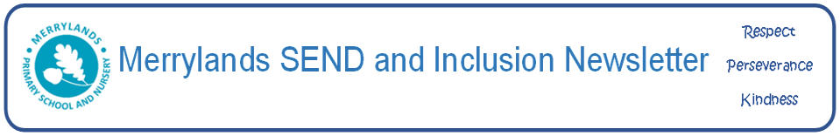
September 2025

Our SEND (Special Educational Needs and Disability) and Inclusion Newsletter will be issued every half term and will include useful articles relating to SEND, links to a wide range of services and useful tips for parents/carers whose child has a special need. In this edition we will explore what SEND actually means.
Special educational needs, often referred to as ‘SEN’ or ‘SEND’, is a term used to describe learning difficulties or disabilities that make it harder for a child to learn compared to children of the same age in the general population.
All children may experience challenges with their learning at some point and for most children, these difficulties can be overcome with support from teachers and at home. However, children with SEND are likely to need extra or different help to be able to learn.

How do you know if a child has SEND?

A child or young person has SEN if:
• They have significantly greater difficulty in learning than the majority of other children and
young people the same age.
• They have a disability which prevents or hinders them from making use of facilities of
a kind generally provided for others of the same age in mainstream schools or
mainstreampost-16 provisions.

A child or young person has a disability if:
• They have a physical and mental impairment which has a substantial and long-term
adverse effect on their ability to carry out day-to-day activities.

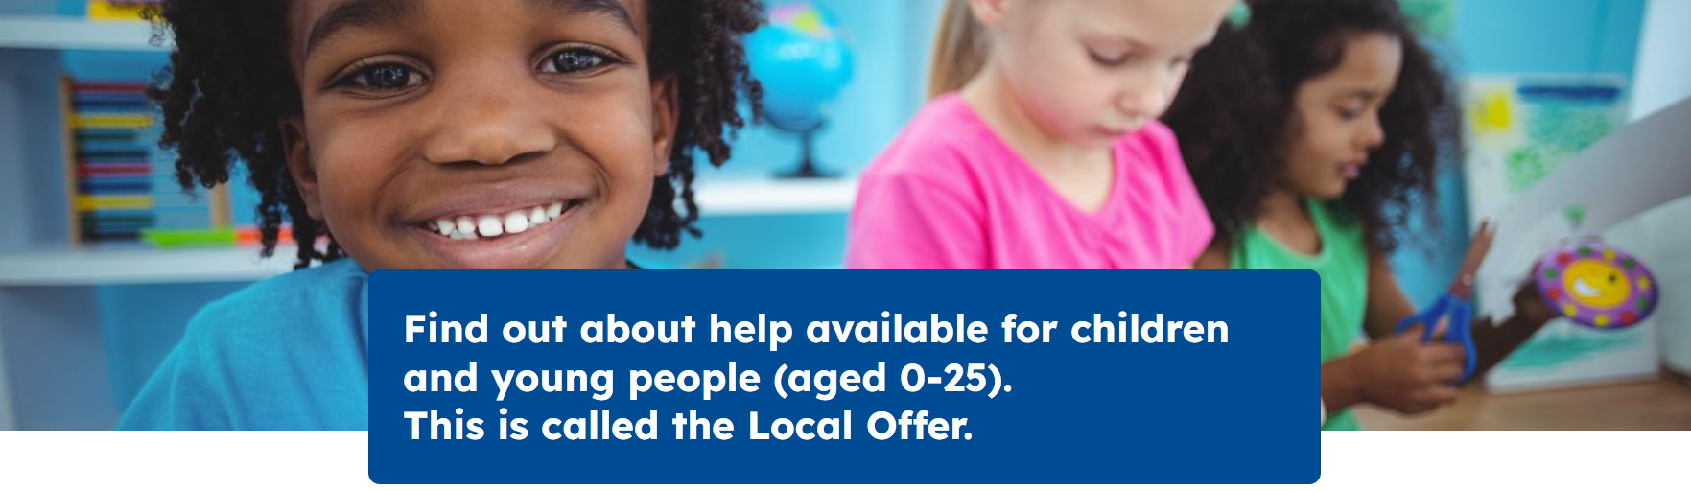
Link to Essex County Council SEND local offer: https://send.essex.gov.uk/#
What types of difficulties are SEND?

Children may have difficulties in one or more of these areas:
Cognition and Learning - A child may find all learning difficult or have difficulties with specific activities such as reading or spelling. A child may have trouble understanding instructions and carrying out tasks. A child may have memory difficulties.
Communication and Interaction - A child may have difficulty in talking to others or under-standing what others are saying to them. A child may have difficulty with interactions with others, such as not being able to take turns. A child who has speech and language needs will be classed as having communication and interaction needs.
Physical and Sensory - A child may have hearing or vision loss. A child may have difficulty with sensory processing, being under or over-sensitive. A child may have a medical condition which affects them physically.
Social, Emotional and Mental Health - A child may display behaviours such as having very low self-esteem or being very anxious. A child may display challenging, disruptive or distressing behaviours. A child may have underlying conditions which affect their mental health.
Further information about available SEND support:

The National Autistic Society
The National Autistic Society (NAS) is the leading charity in the UK dedicated to supporting autistic individuals and their families, providing guidance, advocacy, and services. https://www.autism.org.uk/

Good Beginnings – Autism Information Course for Early Years Parents and Carers
Good Beginnings is an 8-week course for parents and carers of under 5’s all about understanding autism. Dates are available to book for the spring and summer terms in Rochford, Braintree, Witham, Colchester, and online. Parents can join the course to meet other parents, learn about autism, and chat to professionals from education and health. Book a place via the Essex Local Offer website: https://send.essex.gov.uk/search-support-groups-and-activities/good-beginnings-course

My Own Time and Space
My Own Time and Pace (MyOTAS) goal is to improve the lives of Neurodivergent (Autism, ADHD, Dyspraxia, Dyslexia, Sensory Processing Disorder, etc) children, young people and their families.
Mobile: 07840799718 Email: info@myotas.or
https://myotas.org/

